To load import data locally without any abort issues first we need to add this file in desktop. This file is there in sharedpath - \\uszzaschnas01\shared\ITDept\Haritha\sai

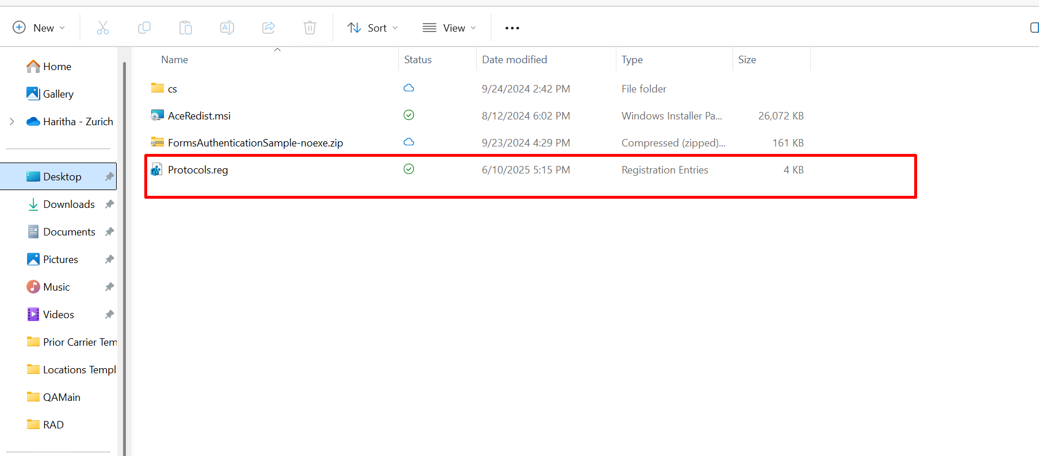
Next open the command prompt in admin mode and execute the file and the file will be activated.
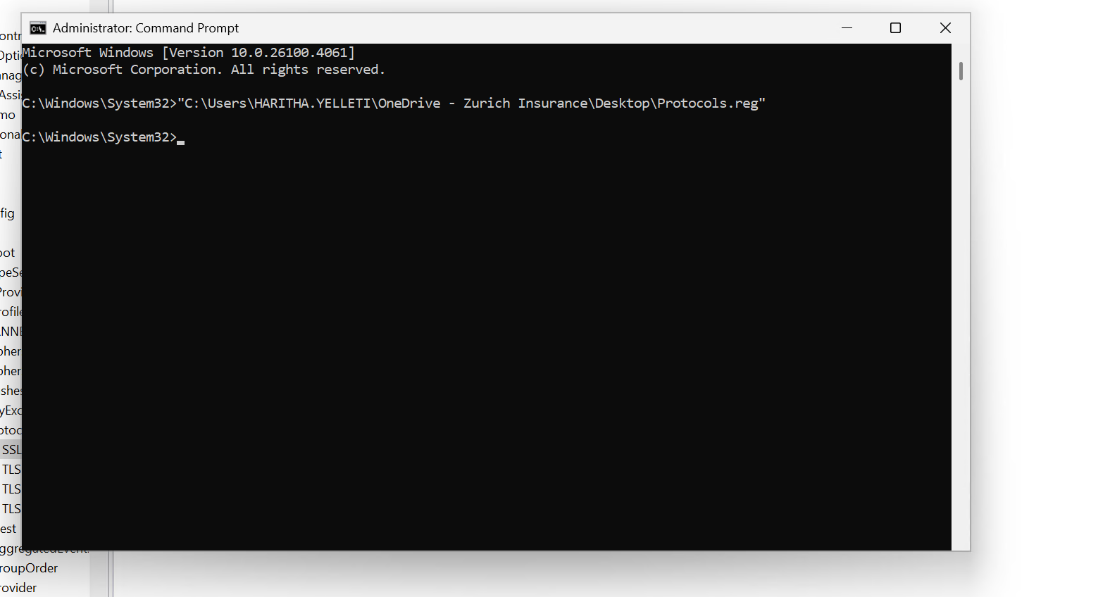
Next in start check for this app ‘Registry editor’ go to the location as in the screenshot and you could observe the TLS
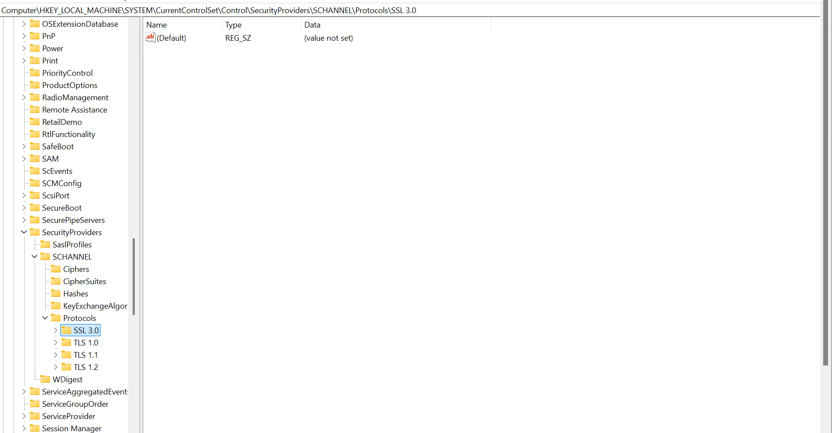

Later add this line in methods ‘GetPRSOptionsforauto’, ‘GetPRSOptionsforGL’,’ GetPRSOptionsforWC’ in singleimportoptioListsx.cs file
ServicePointManager.SecurityProtocol = SecurityProtocolType.Tls | SecurityProtocolType.Tls11 | SecurityProtocolType.Tls12 | SecurityProtocolType.Ssl3;
